Specification connect HMI & ventilator
This document specifies operations of JatSay project for SUWON company.
Revision | Date | Author | Description
1.0 | April 22, 2020 | Nam Pham | - Initial release

Approvals | Title | Date | Signature
Table of Contents
Table of Contents 1
1 Request 2
2 Protocol 3
2.1 Command struct 3
2.2 Command description 4
3 Consult 5
3.1 CRC16 5

Request
  - Use USB-UART for conmunicate.
  - Baud rate 115200, 8bit, no parity.
  - HMI connect board monitor pressure via USB UART 2, it receiver data continuity.
  - HMI connect board Ventilator USB UART, it read and write data setup.

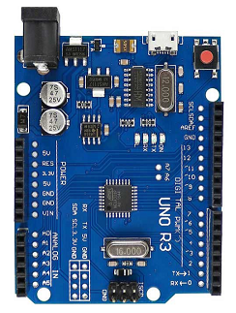
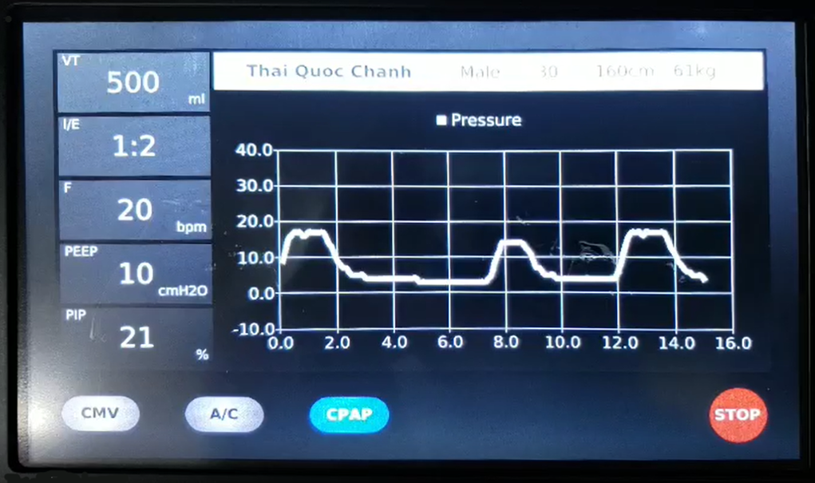
Control Ventilator board
Monitor pressure board
HMI monitoring pressure and setting Ventilator
USB UART 1
USB UART 2

Protocol

Command struct
- Monitor pressure board will send data string: “p,t,0,xxx,yyy”.
  - xxx: pressure unit cm H2O.
  - yyy: timestamp 100ms increment.

- Control Ventilator board flow protocol of Modbus.

Table 0: Command struct
Adress  (1 byte) | Function  (1 byte) | Tran ID  (1 byte) | Len  (2 byte) | Data  (n byte) | CRC16  (2 byte)
a | b | c | d e | e | f g

  - Adress:
Num | Device | Adress | Note
1 | UNO R3 board | 1

  - Function start 101 → 106.
  - Tran ID increment 8 bit (1→255→1).
  - Len (d byte high, e byte low) length of Data (Len = 0 is Data empty).
  - CRC16 (f byte high, g byte).
  - Data

Command description
Table 2: Command Start
Adress  (1 byte) | Function  (1 byte) | Tran ID  (1 byte) | Len  (2 byte) | Data  (n byte) | CRC16  (2 byte) | Note
1 | 101 |  | 0 | - |  | HMI send
1 | 101 |  | 1 | 1 |  | HMI read

Table 3: Command Stop
Adress  (1 byte) | Function  (1 byte) | Tran ID  (1 byte) | Len  (2 byte) | Data  (n byte) | CRC16  (2 byte) | Note
1 | 102 |  | 0 | - |  | HMI send
1 | 102 |  | 1 | 1 |  | HMI read

Table 4: Command read
Adress  (1 byte) | Function  (1 byte) | Tran ID  (1 byte) | Len  (2 byte) | Data  (n byte) | CRC16  (2 byte) | Note
1 | 103 |  | 0 | - |  | HMI send
1 | 103 |  | 9 | Data |  | HMI read

Table 5: Command write
Adress  (1 byte) | Function  (1 byte) | Tran ID  (1 byte) | Len  (2 byte) | Data  (n byte) | CRC16  (2 byte) | Note
1 | 104 |  | 9 | Data |  | HMI send
1 | 104 |  | 9 | Data |  | HMI read after Ventilator calculate F

Data read and write of setup.
byte | data | Note
0 | Mode | = 1: A/C VC  = 2: SIMV + VS  = 3: PRVC
1, 2 | Vt | 1 byte high, 2 byte low
3, 4 | Ti
5 | F
6 | PEEP
7 | PIP
8 | PS

Table 5: Command Buzzer
Adress  (1 byte) | Function  (1 byte) | Tran ID  (1 byte) | Len  (2 byte) | Data  (n byte) | CRC16  (2 byte) | Note
1 | 105 |  | 1 | 0-255 (s) |  | - Data: Time turn on buzzer.  - Data = 0: Buzzer off.
1 | 105 |  | 1 | 0-255 (s)

Table 6: Command Ask Device Control
Adress  (1 byte) | Function  (1 byte) | Tran ID  (1 byte) | Len  (2 byte) | Data  (n byte) | CRC16  (2 byte) | Note
1 | 106 |  | 0 | -
1 | 106 |  | 1 | 1

Consult

CRC16

/* Table of CRC values for high-order byte */
static const unsigned char table_crc_hi[] = {
0x00, 0xC1, 0x81, 0x40, 0x01, 0xC0, 0x80, 0x41, 0x01, 0xC0,
0x80, 0x41, 0x00, 0xC1, 0x81, 0x40, 0x01, 0xC0, 0x80, 0x41,
0x00, 0xC1, 0x81, 0x40, 0x00, 0xC1, 0x81, 0x40, 0x01, 0xC0,
0x80, 0x41, 0x01, 0xC0, 0x80, 0x41, 0x00, 0xC1, 0x81, 0x40,
0x00, 0xC1, 0x81, 0x40, 0x01, 0xC0, 0x80, 0x41, 0x00, 0xC1,
0x81, 0x40, 0x01, 0xC0, 0x80, 0x41, 0x01, 0xC0, 0x80, 0x41,
0x00, 0xC1, 0x81, 0x40, 0x01, 0xC0, 0x80, 0x41, 0x00, 0xC1,
0x81, 0x40, 0x00, 0xC1, 0x81, 0x40, 0x01, 0xC0, 0x80, 0x41,
0x00, 0xC1, 0x81, 0x40, 0x01, 0xC0, 0x80, 0x41, 0x01, 0xC0,
0x80, 0x41, 0x00, 0xC1, 0x81, 0x40, 0x00, 0xC1, 0x81, 0x40,
0x01, 0xC0, 0x80, 0x41, 0x01, 0xC0, 0x80, 0x41, 0x00, 0xC1,
0x81, 0x40, 0x01, 0xC0, 0x80, 0x41, 0x00, 0xC1, 0x81, 0x40,
0x00, 0xC1, 0x81, 0x40, 0x01, 0xC0, 0x80, 0x41, 0x01, 0xC0,
0x80, 0x41, 0x00, 0xC1, 0x81, 0x40, 0x00, 0xC1, 0x81, 0x40,
0x01, 0xC0, 0x80, 0x41, 0x00, 0xC1, 0x81, 0x40, 0x01, 0xC0,
0x80, 0x41, 0x01, 0xC0, 0x80, 0x41, 0x00, 0xC1, 0x81, 0x40,
0x00, 0xC1, 0x81, 0x40, 0x01, 0xC0, 0x80, 0x41, 0x01, 0xC0,
0x80, 0x41, 0x00, 0xC1, 0x81, 0x40, 0x01, 0xC0, 0x80, 0x41,
0x00, 0xC1, 0x81, 0x40, 0x00, 0xC1, 0x81, 0x40, 0x01, 0xC0,
0x80, 0x41, 0x00, 0xC1, 0x81, 0x40, 0x01, 0xC0, 0x80, 0x41,
0x01, 0xC0, 0x80, 0x41, 0x00, 0xC1, 0x81, 0x40, 0x01, 0xC0,
0x80, 0x41, 0x00, 0xC1, 0x81, 0x40, 0x00, 0xC1, 0x81, 0x40,
0x01, 0xC0, 0x80, 0x41, 0x01, 0xC0, 0x80, 0x41, 0x00, 0xC1,
0x81, 0x40, 0x00, 0xC1, 0x81, 0x40, 0x01, 0xC0, 0x80, 0x41,
0x00, 0xC1, 0x81, 0x40, 0x01, 0xC0, 0x80, 0x41, 0x01, 0xC0,
0x80, 0x41, 0x00, 0xC1, 0x81, 0x40
};

/* Table of CRC values for low-order byte */
static const unsigned char table_crc_lo[] = {
0x00, 0xC0, 0xC1, 0x01, 0xC3, 0x03, 0x02, 0xC2, 0xC6, 0x06,
0x07, 0xC7, 0x05, 0xC5, 0xC4, 0x04, 0xCC, 0x0C, 0x0D, 0xCD,
0x0F, 0xCF, 0xCE, 0x0E, 0x0A, 0xCA, 0xCB, 0x0B, 0xC9, 0x09,
0x08, 0xC8, 0xD8, 0x18, 0x19, 0xD9, 0x1B, 0xDB, 0xDA, 0x1A,
0x1E, 0xDE, 0xDF, 0x1F, 0xDD, 0x1D, 0x1C, 0xDC, 0x14, 0xD4,
0xD5, 0x15, 0xD7, 0x17, 0x16, 0xD6, 0xD2, 0x12, 0x13, 0xD3,
0x11, 0xD1, 0xD0, 0x10, 0xF0, 0x30, 0x31, 0xF1, 0x33, 0xF3,
0xF2, 0x32, 0x36, 0xF6, 0xF7, 0x37, 0xF5, 0x35, 0x34, 0xF4,
0x3C, 0xFC, 0xFD, 0x3D, 0xFF, 0x3F, 0x3E, 0xFE, 0xFA, 0x3A,
0x3B, 0xFB, 0x39, 0xF9, 0xF8, 0x38, 0x28, 0xE8, 0xE9, 0x29,
0xEB, 0x2B, 0x2A, 0xEA, 0xEE, 0x2E, 0x2F, 0xEF, 0x2D, 0xED,
0xEC, 0x2C, 0xE4, 0x24, 0x25, 0xE5, 0x27, 0xE7, 0xE6, 0x26,
0x22, 0xE2, 0xE3, 0x23, 0xE1, 0x21, 0x20, 0xE0, 0xA0, 0x60,
0x61, 0xA1, 0x63, 0xA3, 0xA2, 0x62, 0x66, 0xA6, 0xA7, 0x67,
0xA5, 0x65, 0x64, 0xA4, 0x6C, 0xAC, 0xAD, 0x6D, 0xAF, 0x6F,
0x6E, 0xAE, 0xAA, 0x6A, 0x6B, 0xAB, 0x69, 0xA9, 0xA8, 0x68,
0x78, 0xB8, 0xB9, 0x79, 0xBB, 0x7B, 0x7A, 0xBA, 0xBE, 0x7E,
0x7F, 0xBF, 0x7D, 0xBD, 0xBC, 0x7C, 0xB4, 0x74, 0x75, 0xB5,
0x77, 0xB7, 0xB6, 0x76, 0x72, 0xB2, 0xB3, 0x73, 0xB1, 0x71,
0x70, 0xB0, 0x50, 0x90, 0x91, 0x51, 0x93, 0x53, 0x52, 0x92,
0x96, 0x56, 0x57, 0x97, 0x55, 0x95, 0x94, 0x54, 0x9C, 0x5C,
0x5D, 0x9D, 0x5F, 0x9F, 0x9E, 0x5E, 0x5A, 0x9A, 0x9B, 0x5B,
0x99, 0x59, 0x58, 0x98, 0x88, 0x48, 0x49, 0x89, 0x4B, 0x8B,
0x8A, 0x4A, 0x4E, 0x8E, 0x8F, 0x4F, 0x8D, 0x4D, 0x4C, 0x8C,
0x44, 0x84, 0x85, 0x45, 0x87, 0x47, 0x46, 0x86, 0x82, 0x42,
0x43, 0x83, 0x41, 0x81, 0x80, 0x40
};

unsigned short crc16(byte *buffer, int buffer_length)
{
unsigned char crc_hi = 0xFF; /* high CRC byte initialized */
unsigned char crc_lo = 0xFF; /* low CRC byte initialized */
unsigned int i; /* will index into CRC lookup */

/* pass through message buffer */
while (buffer_length--) {
i = crc_hi ^ *buffer++; /* calculate the CRC */
crc_hi = crc_lo ^ table_crc_hi[i];
crc_lo = table_crc_lo[i];
}

return (crc_hi << 8 | crc_lo);
}

